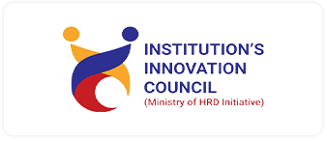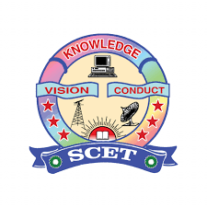 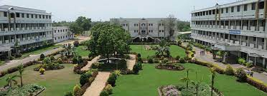

INSTITUTION’S INNOVATION COUNCIL(IIC)

**SWARNANDHRA**

COLLEGE OF ENGINEERING AND TECHNOLOGY

**Seetharampuram, Narsapur.**

**Report of Workshop on Effective Sales and Marketing Strategies for Start-ups**

|  |  |
| --- | --- |
| **Social Media** | |
| Face book | Swarnandhra Autonomous |
| YouTube | SCET -IQAC |

|  |  |
| --- | --- |
| Academic Year | 2025-2026 |
| Program driven by | IIC MIC activity |
| Quarter | II |
| Title of the Program | Workshop on Effective Sales and Marketing Strategies for Start-ups |
| Programme Type | Level -1 Expert Talk |
| Programme Theme/Thrust area | Q2-Entrepreneurship Development and Startup Growth through Effective Sales and Marketing Strategies |
| Program Start Date | 24/12/2025 |
| Program End Date | 24/12/2025 |
| Duration | 2 hour |
| Number of Students Participants | 72 |
| Number of Faculty Participants | 5 |
| Mode of Delivery | offline |
| Program Objectives | To provide participants with a strong foundation in **sales and marketing concepts** relevant to startups, To help entrepreneurs identify and understand their **target customers and market segments** |

|  |  |
| --- | --- |
| Benefits in terms of learning/skill/knowledge development | Gained a clear understanding of how **sales and marketing work in startup environments,** Developed practical skills in **identifying target customers and market segmentation** |
| Faculty Coordinator | Mr.R V Manikanta, Assistant Professor, Dept. of AIML |

**Programme/ Event Report**

The Institution’s Innovation Council (IIC) of Swarnandhra College of Engineering, in collaboration with the Department of AIML, organized a dedicated Workshop on Effective Sales and Marketing Strategies for Start-ups. As part of this initiative, comprehensive arrangements were made to facilitate student participation in the live telecast of “Effective Sales and Marketing Strategies for Start-ups” a distinguished edition of the ongoing interaction series with students. This remarkable initiative provided participants with valuable insights into **effective sales and marketing strategies**, particularly in the context of startups. Attendees gained comprehensive knowledge of customer acquisition, branding, digital promotion, and practical sales techniques, enabling them to understand how innovative ideas can be successfully introduced to the market.

The session on **“Effective Sales and Marketing Strategies for Startups”** was a resounding success, achieving its objective of spreading awareness and strengthening entrepreneurial skills among students. It not only enriched their understanding of market analysis, value proposition design, and customer engagement strategies but also inspired them to approach business challenges with confidence, creativity, and strategic thinking.

Overall, the event clearly reflected the institution’s commitment to nurturing an **entrepreneurial and innovation-driven ecosystem** on campus, empowering students to transform their ideas into sustainable and market-ready ventures.

**Event Photo**

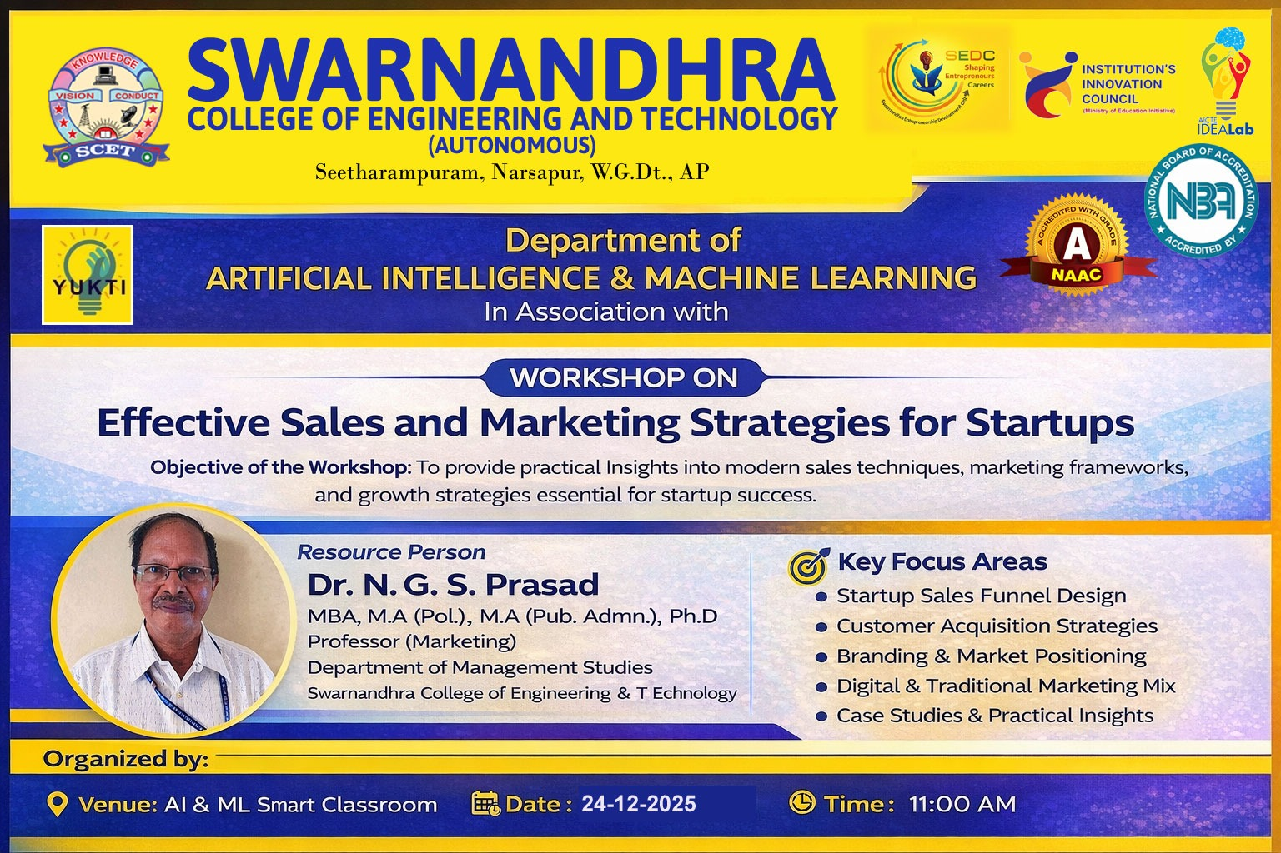

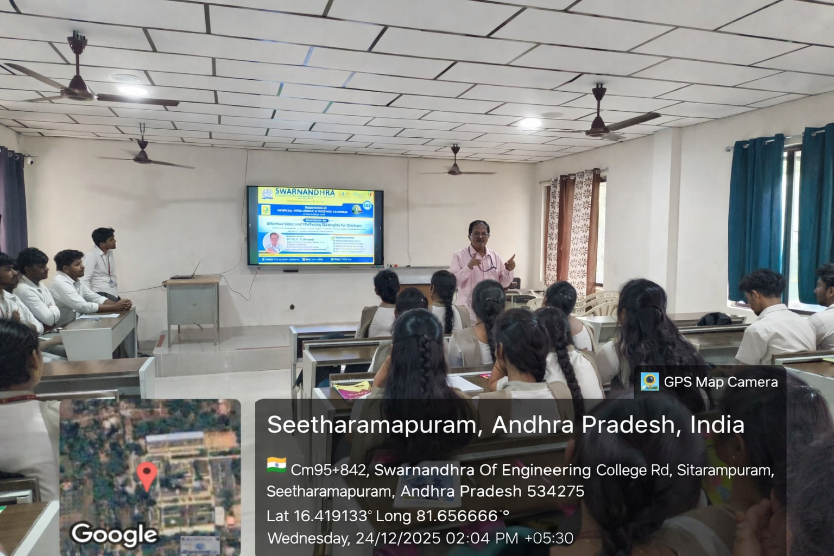

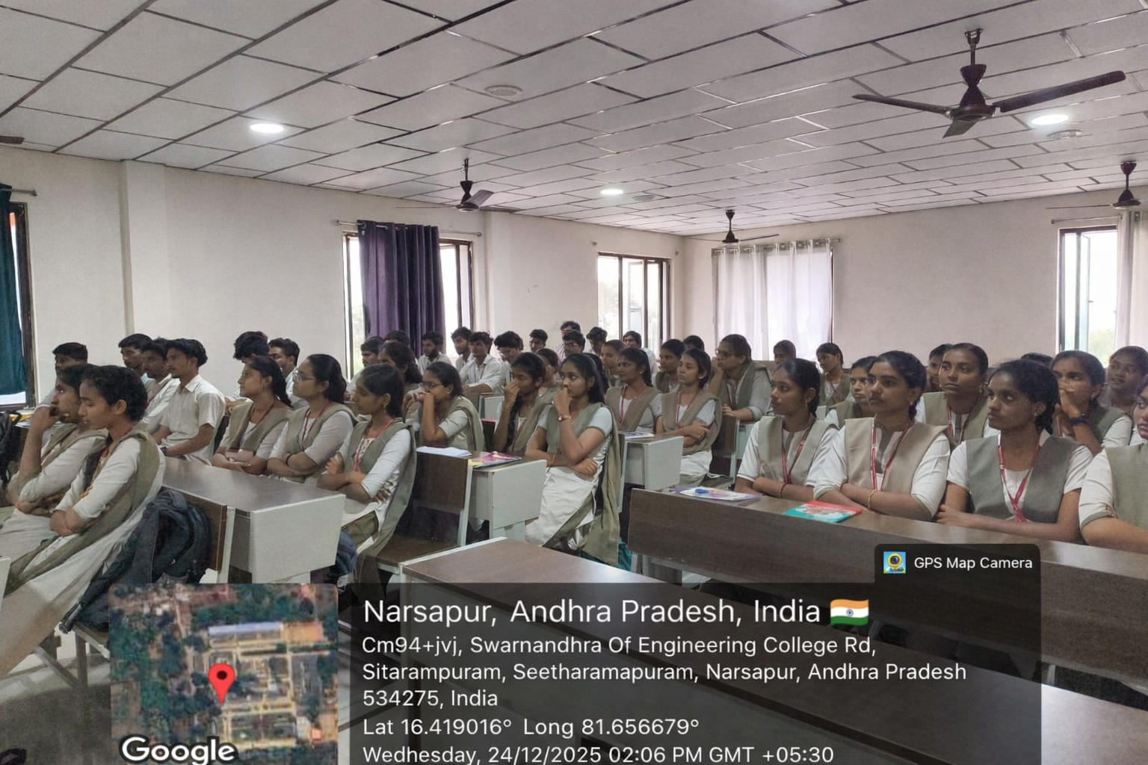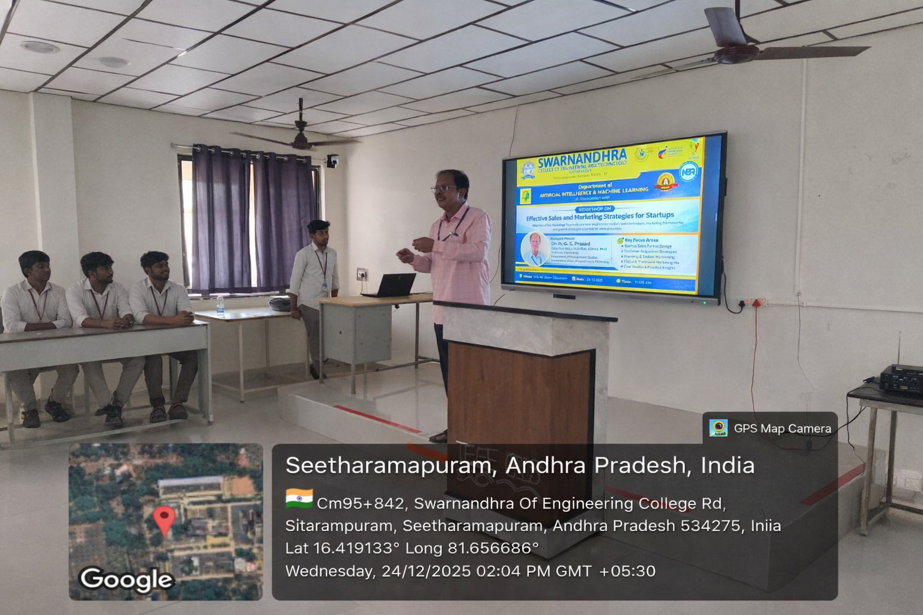

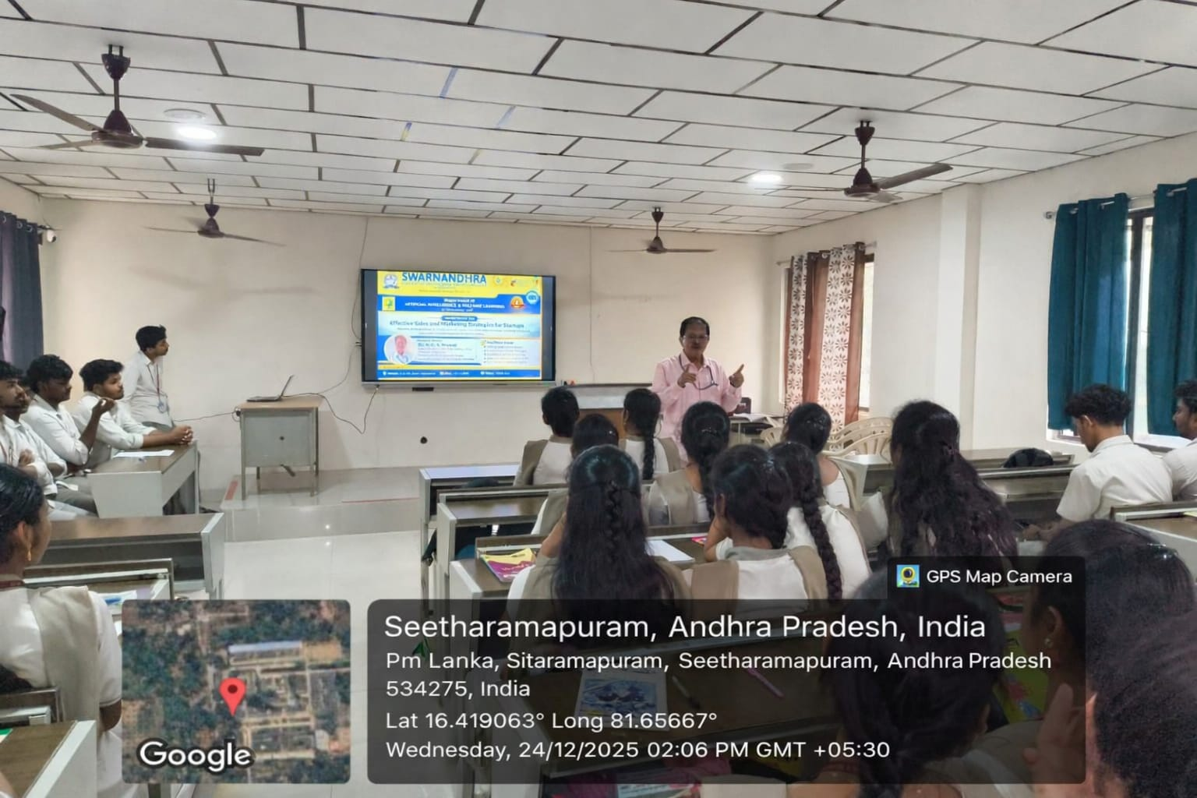

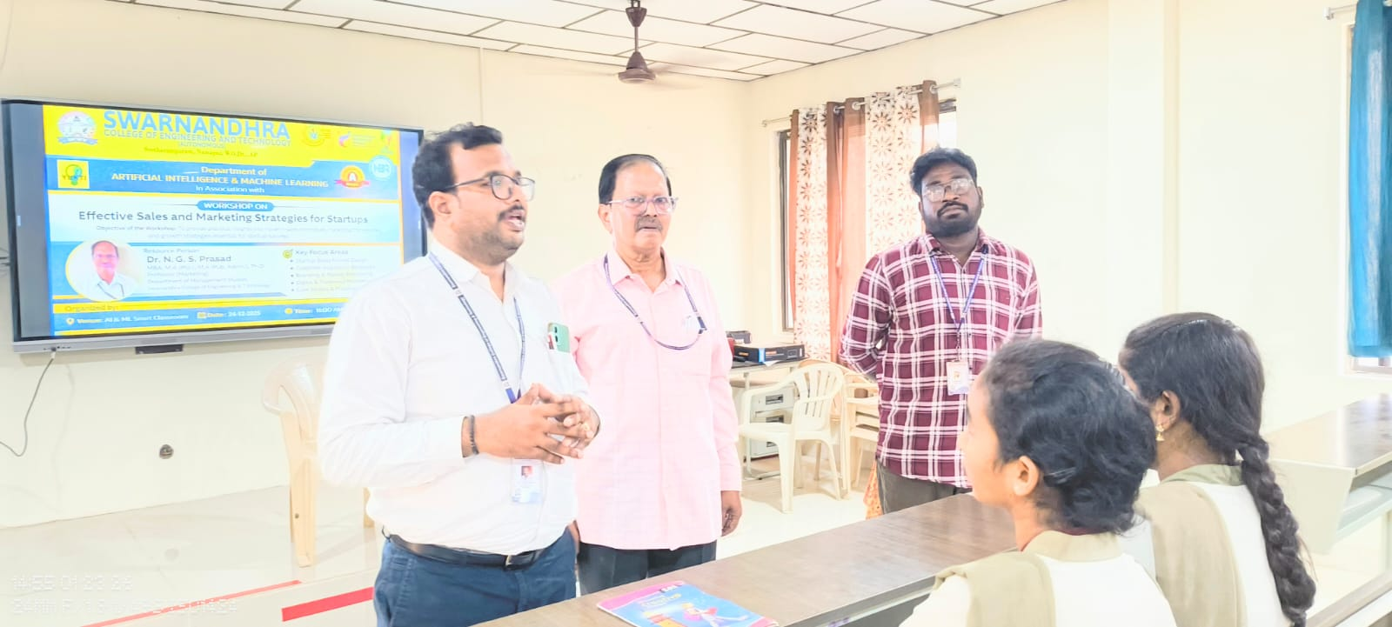

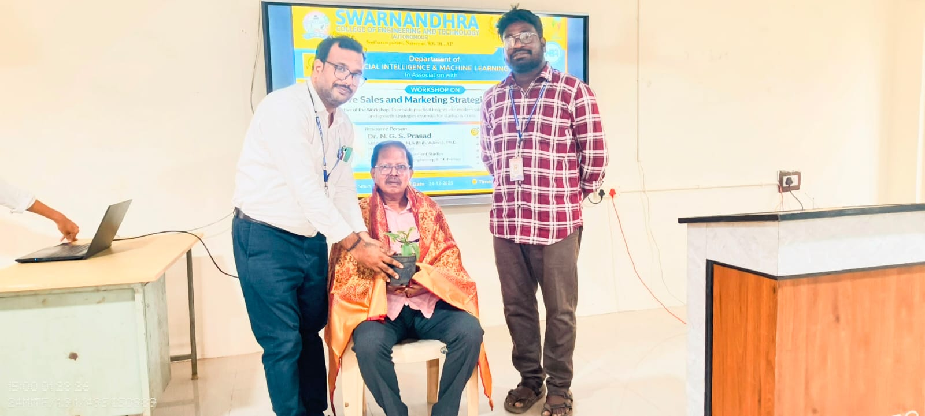

**Participants List**

